Project Topic - ResuMatch

Problem Statement:
Job seekers often struggle to create resumes that are optimized for Applicant Tracking Systems (ATS) and aligned with job descriptions. As a result, highly qualified candidates get overlooked, and companies miss out on top talent. There is a lack of accessible, intelligent tools that bridge this gap efficiently and effectively.

Goal:
To build a smart resume analyzer that gives ATS-based match scores, helping job seekers tailor their resumes for specific job roles.

Introduction:
ResuMatch is a smart resume analysis tool designed to help job seekers tailor their resumes for specific job roles. Built with advanced comparison algorithms and powered by cloud infrastructure, it provides deep insights into how well a resume aligns with a job description.

Features of ResuMatch:

1. Cloud-Based Storage with S3 Integration:
Stores all user-uploaded resumes securely in Amazon S3.
Enables fast retrieval and download for authenticated users.

2. History of Resume Uploads:
User can view his/her previously uploaded resumes.

3. PDF Viewer with Preview / Delete / Download:
Integrated file viewer for ease of access.
Access ATS scores, edit or delete anytime.

4. User Authentication via AWS Cognito:
Secure login/signup system.
Protects data and enables user-specific history

5. AI-Powered Scoring Engine:
Analyzes resumes for ATS compatibility.
Generates a score based on keywords, format, and job relevance.

6. Secure API Gateway Integration:
All resume uploads and analysis requests are routed through AWS API Gateway.
Secures backend communication and data validation.

Tech Stack used:

Frontend:

1. HTML5 – Structures the web content.
2. CSS3 – Styles the website and makes it responsive.
3. JavaScript – Adds interactivity to the platform.

Backend:

1. AWS Lambda – Runs backend code without managing servers.
2. Amazon S3 – Stores uploaded resume files securely.
3. API Gateway – Routes API requests between frontend and backend.
4. AWS Cognito – Manages user authentication (login/signup).
5. Amazon DynamoDB – Stores user data.
6. Amazon Textract – Extracts text from resume PDFs.
7. Amazon Comprehend – Analyzes extracted text to understand skills, entities, and context for better JD matching.

Project Steps:

Step 1: User signs up/logs in using through frontend which will be stored in AWS Cognito.
Step 2: User will upload the Resume via UI which will be stored in S3.
Step 3: If user has the job description, the User pastes it (optional step)
Step 4: Amazon Textract extracts the texts from Resume and Amazon Comprehend analyses the text and gives ATS matching score. This all process is done in the backend
Step 5: Once this is done, the ATS score, improvement suggestions and Job recommendations are shown.
Step 6: User can view their Resume history with Edit/Delete/Download options.
Step 7: User can logout from the website if they want.

Architectural diagram:
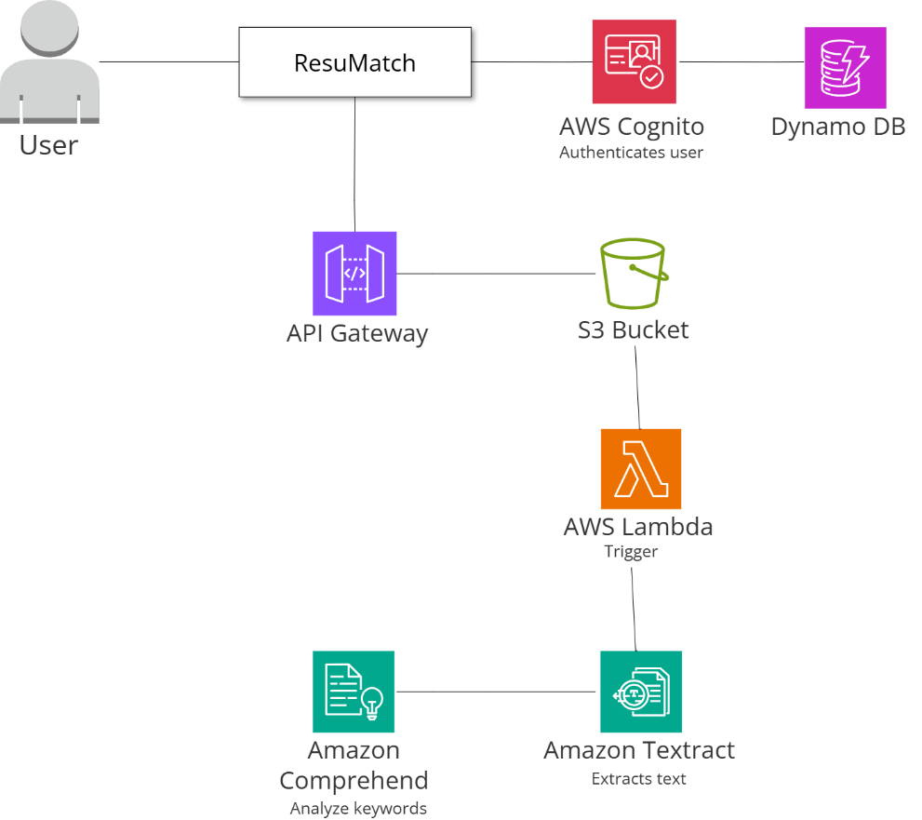

ResuMatch screenshots:
Signup:
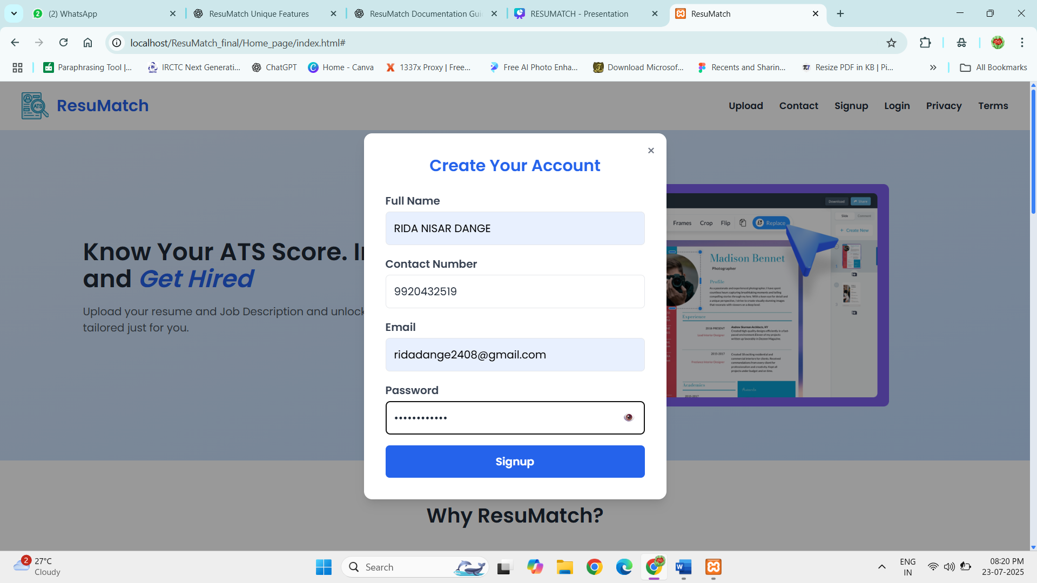

Home page:
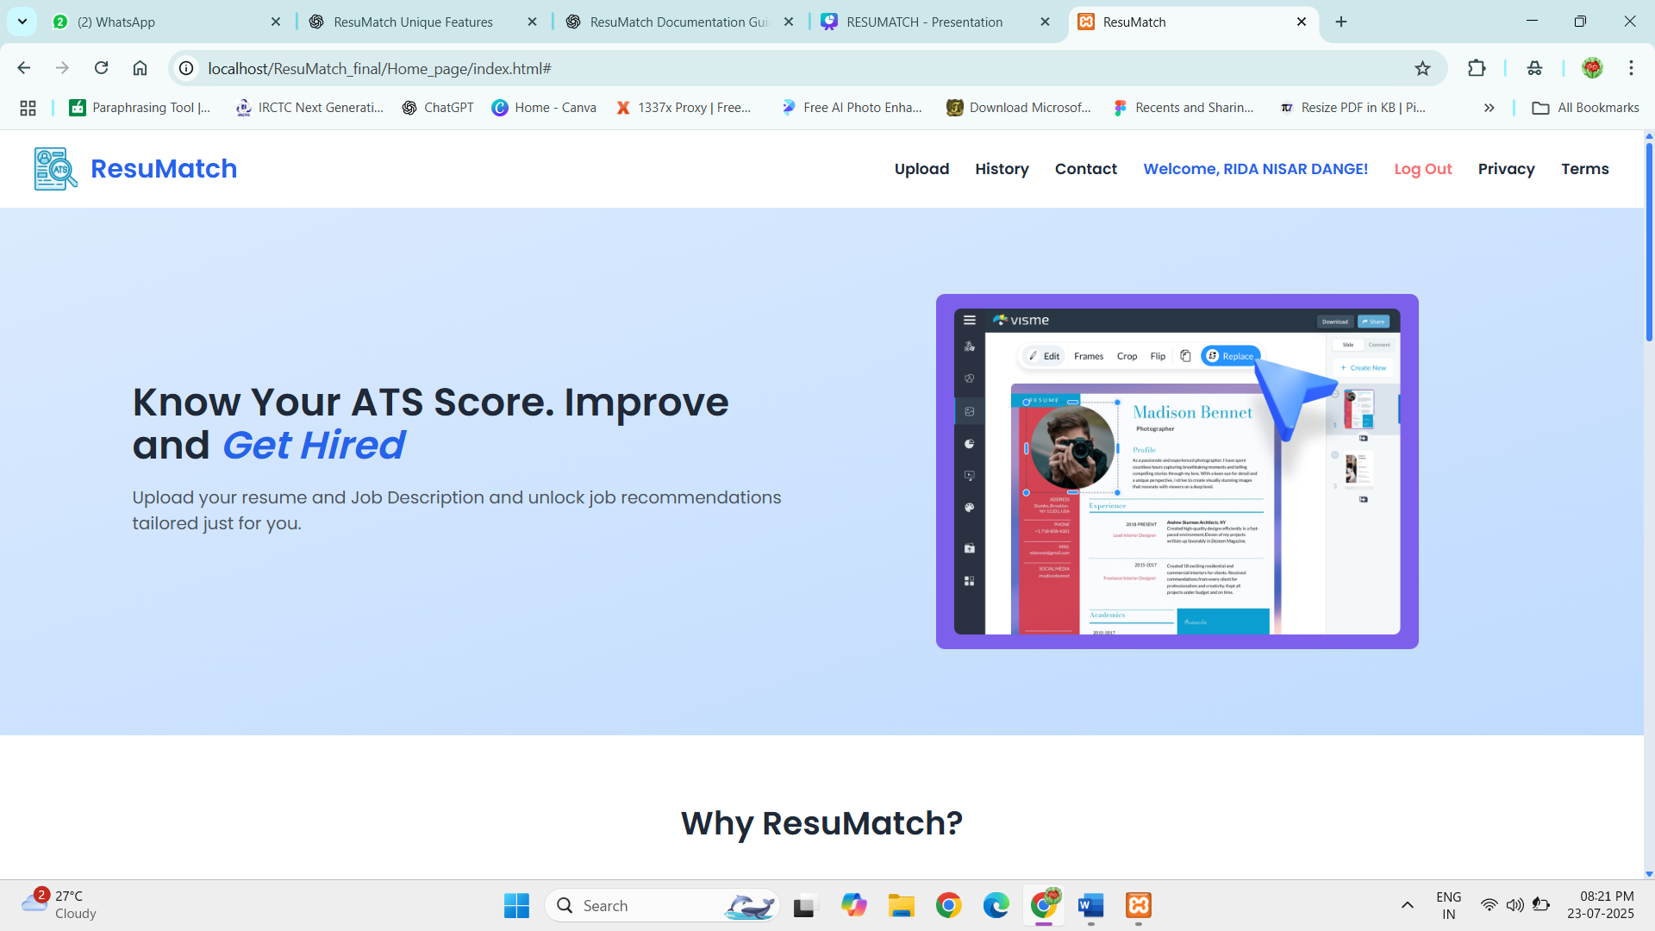
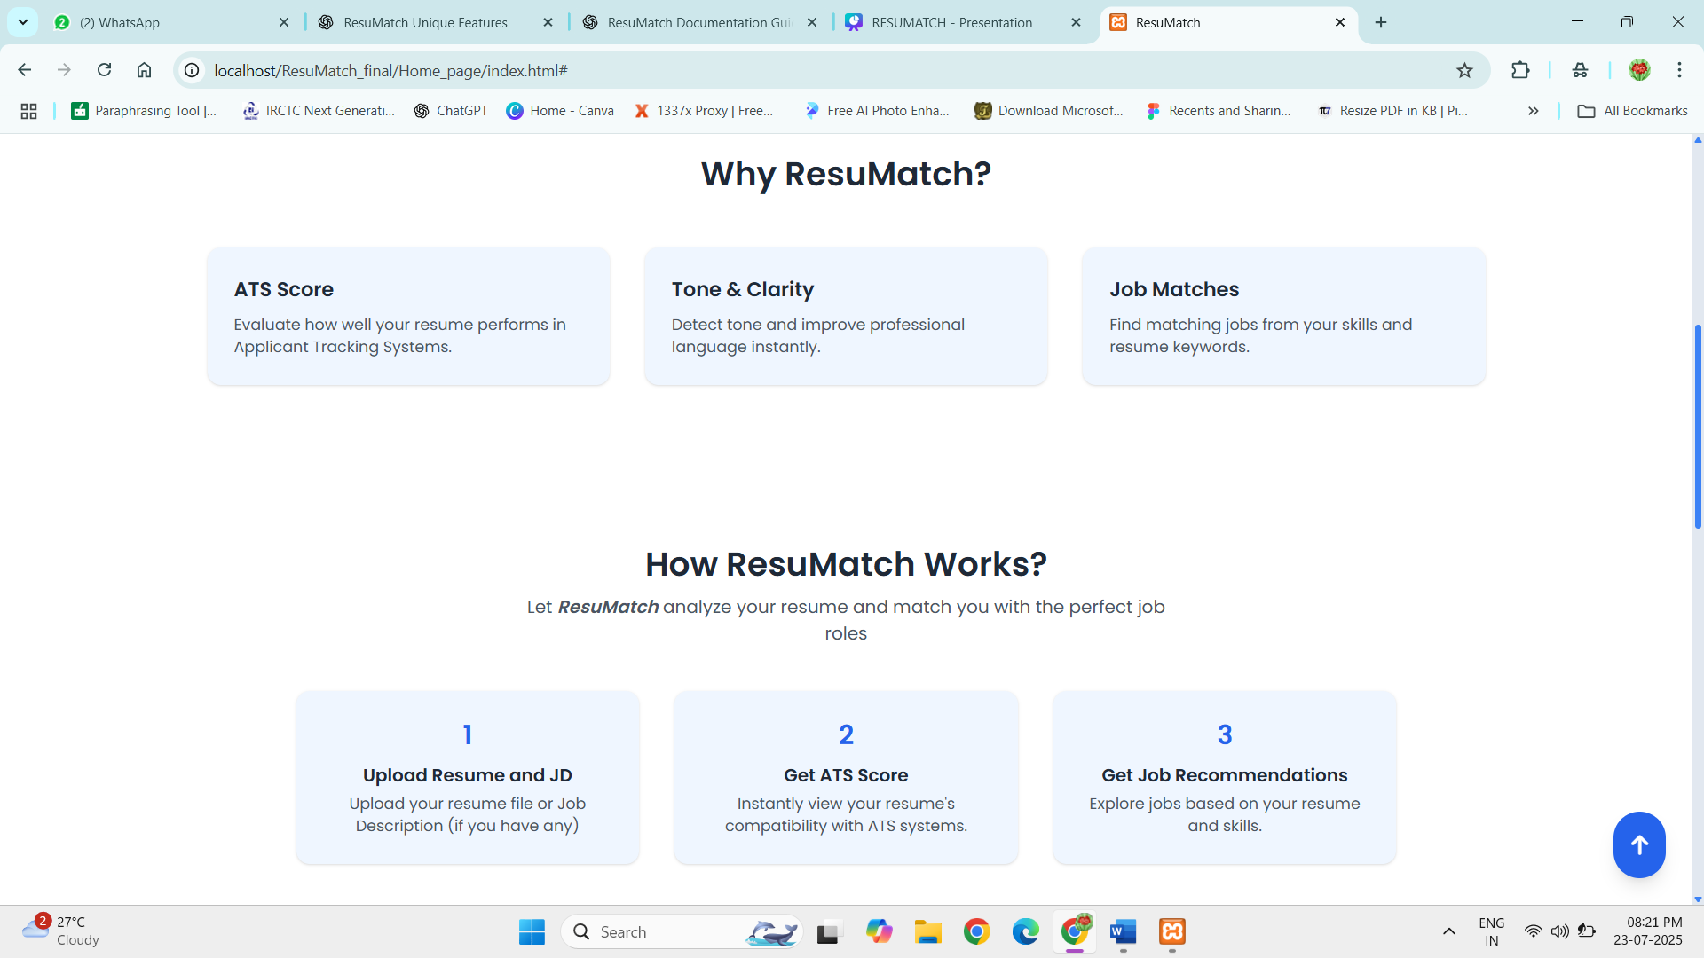
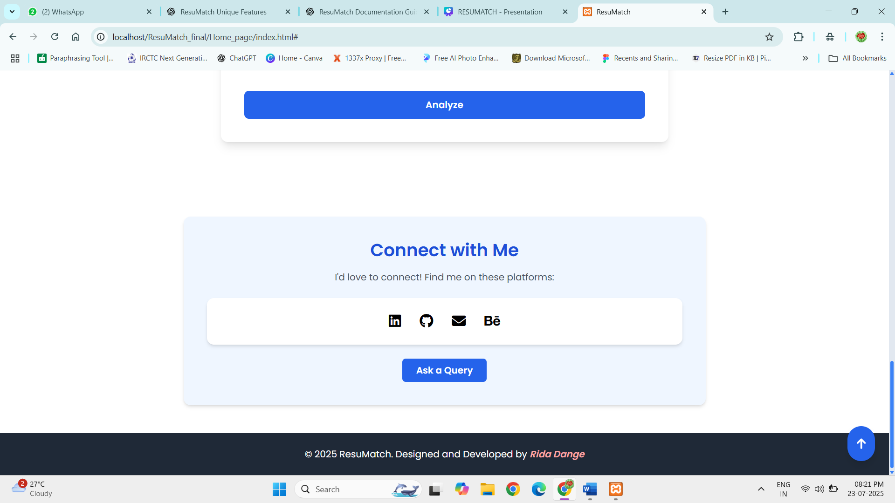
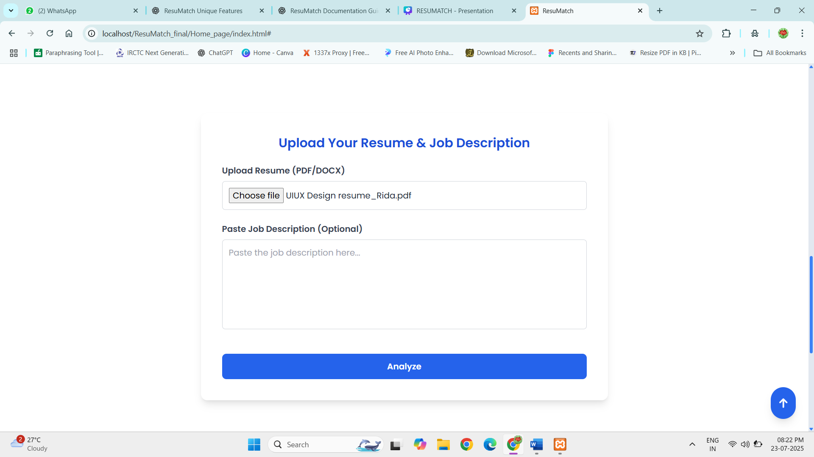

Analysis page:
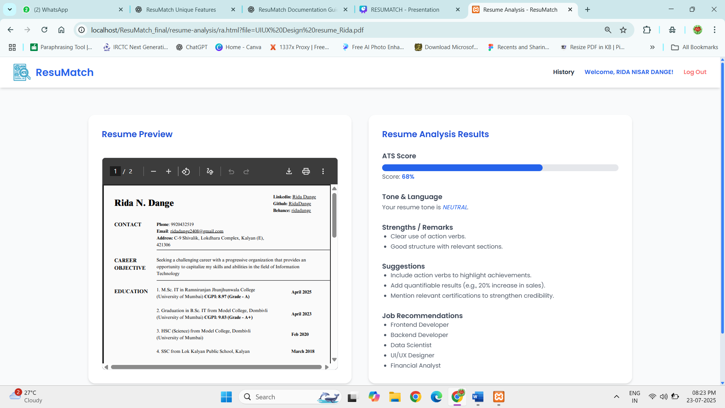

History page:
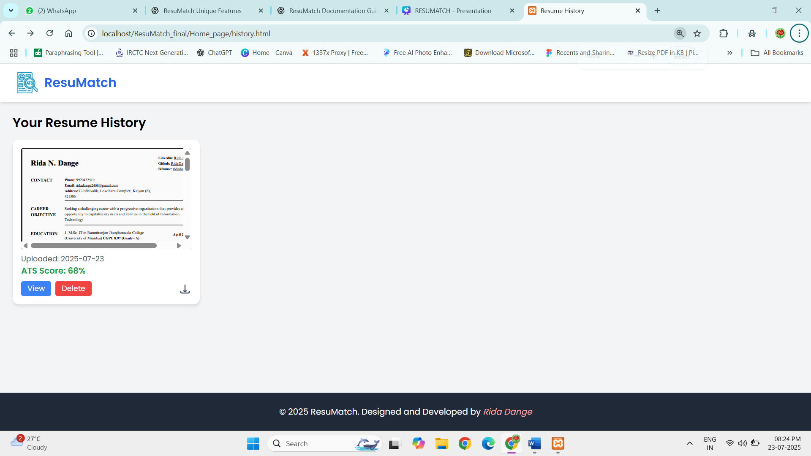

Amazon DynamoDB: Where user data is getting stored
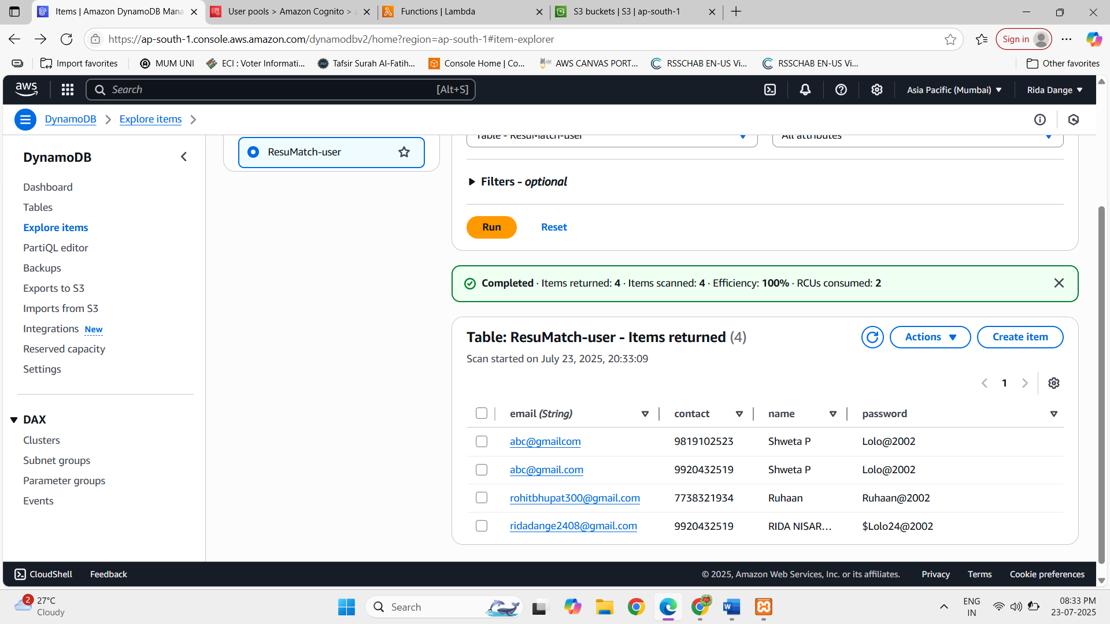

AWS Cognito: Where user is authenticated and confirmed by cognito
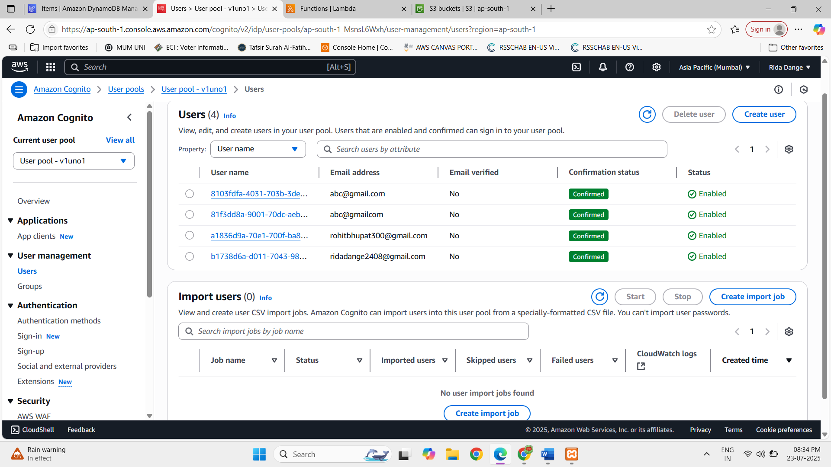

Lambda function:
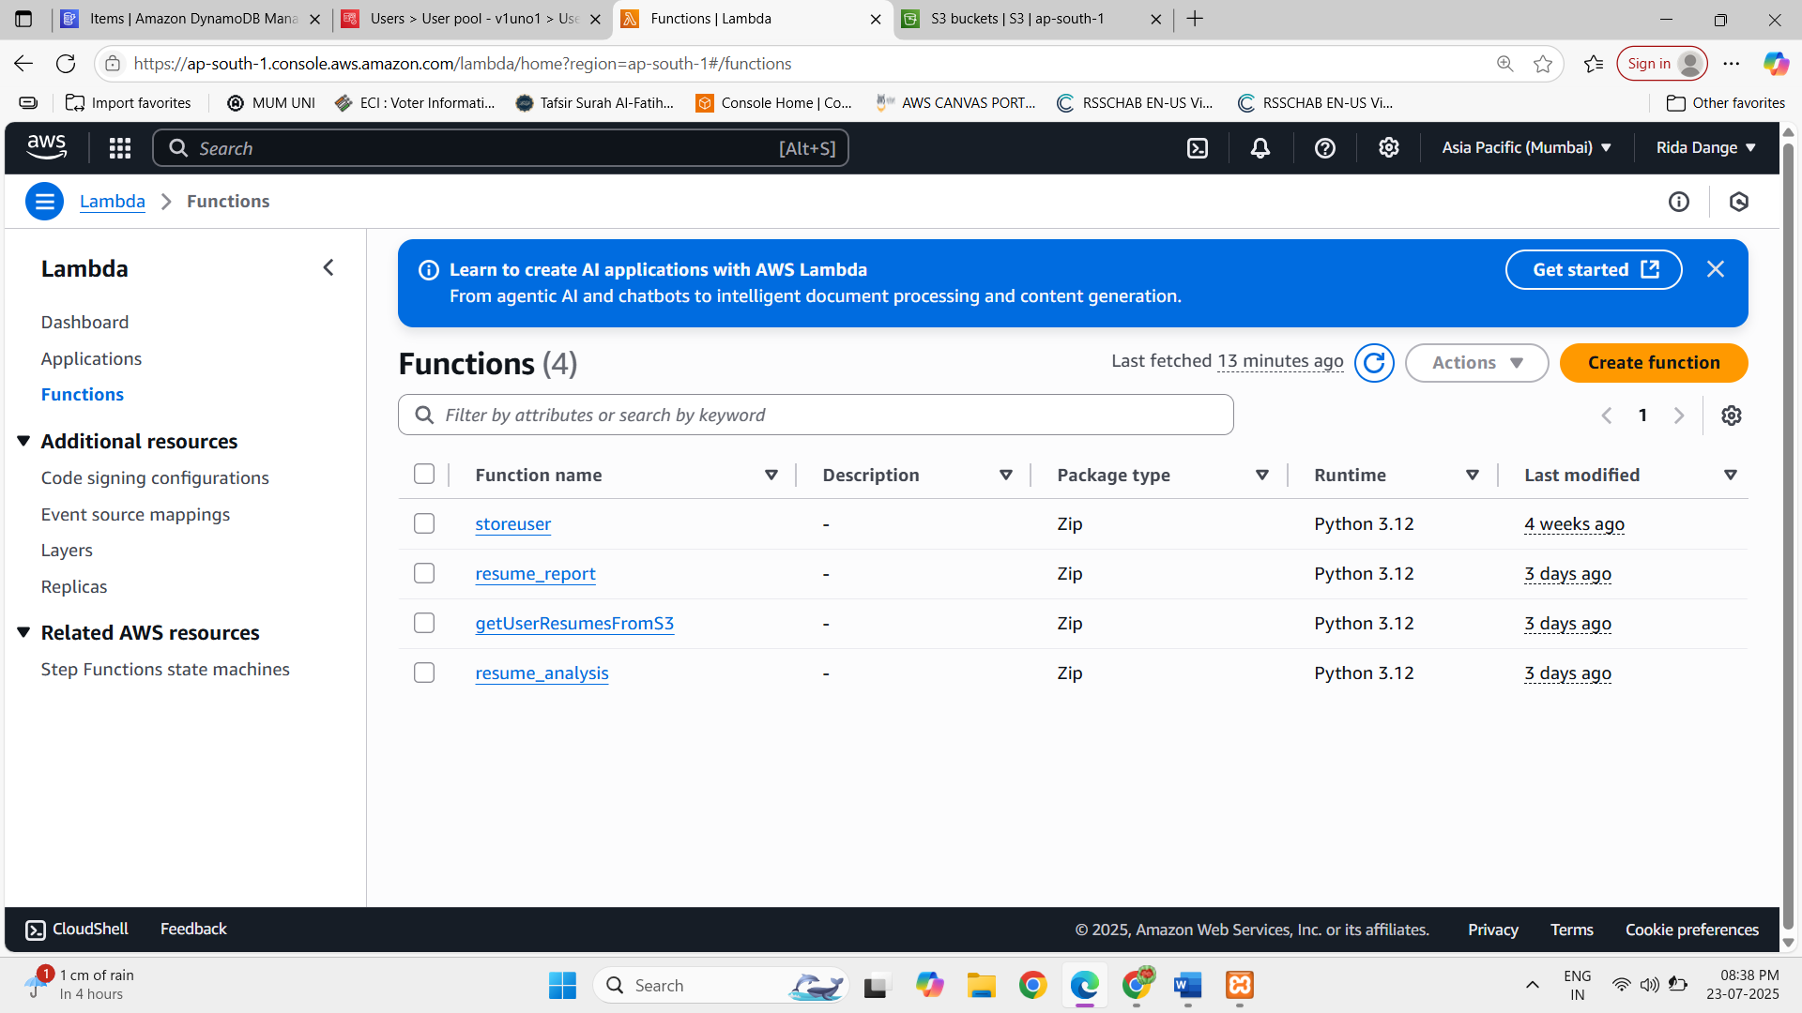

Storeuser function: Here code for storing the user is written
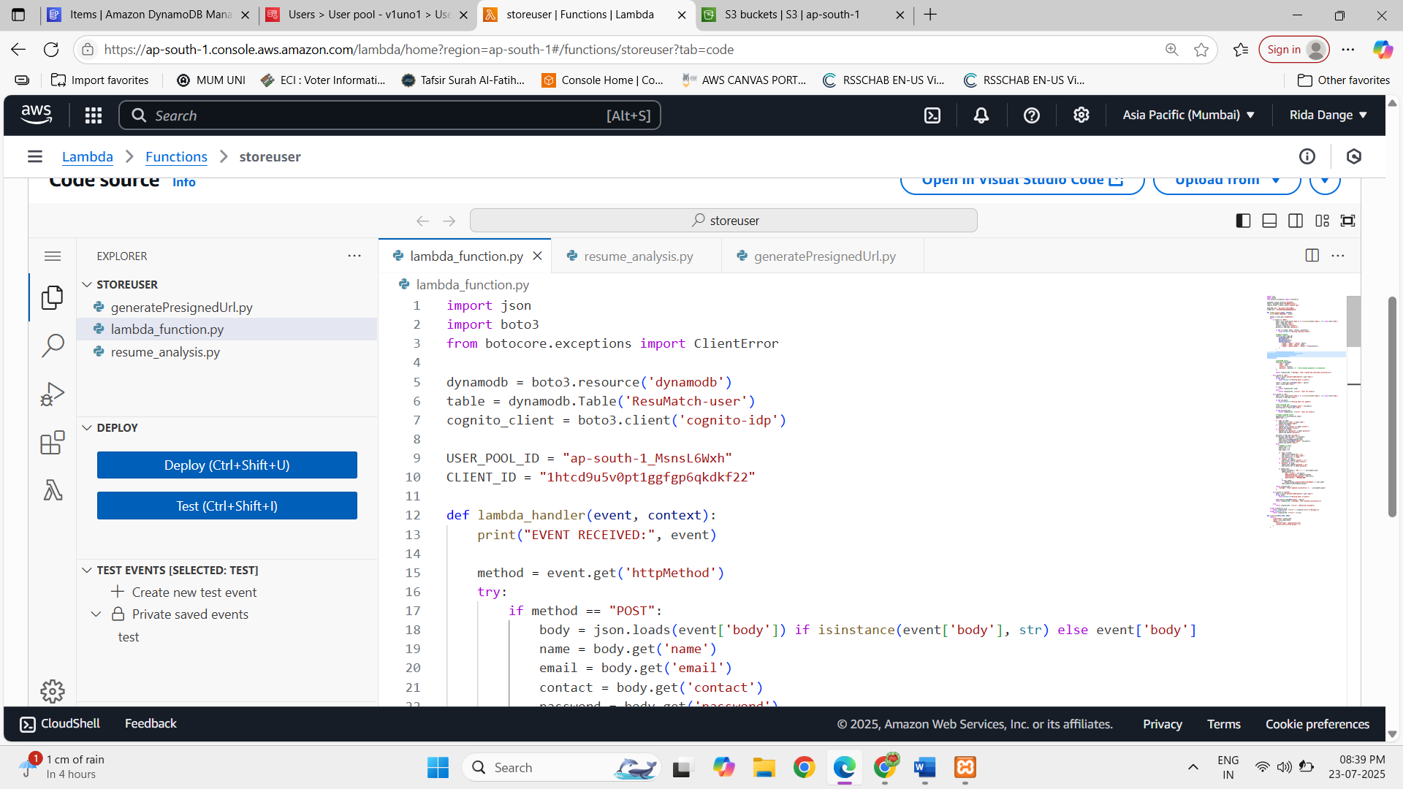

Resume report function: here the report generated after resume upload is written
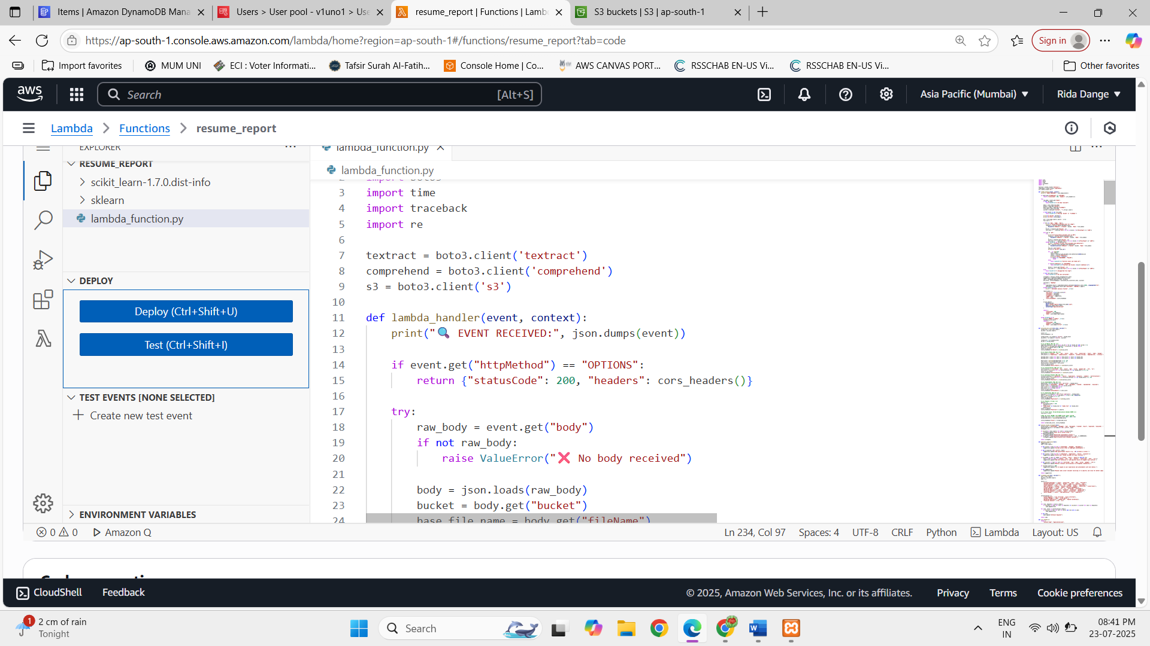

getUserResumesFromS3 fuction: Here resumes should be fetch from backend and displayed in history is written.
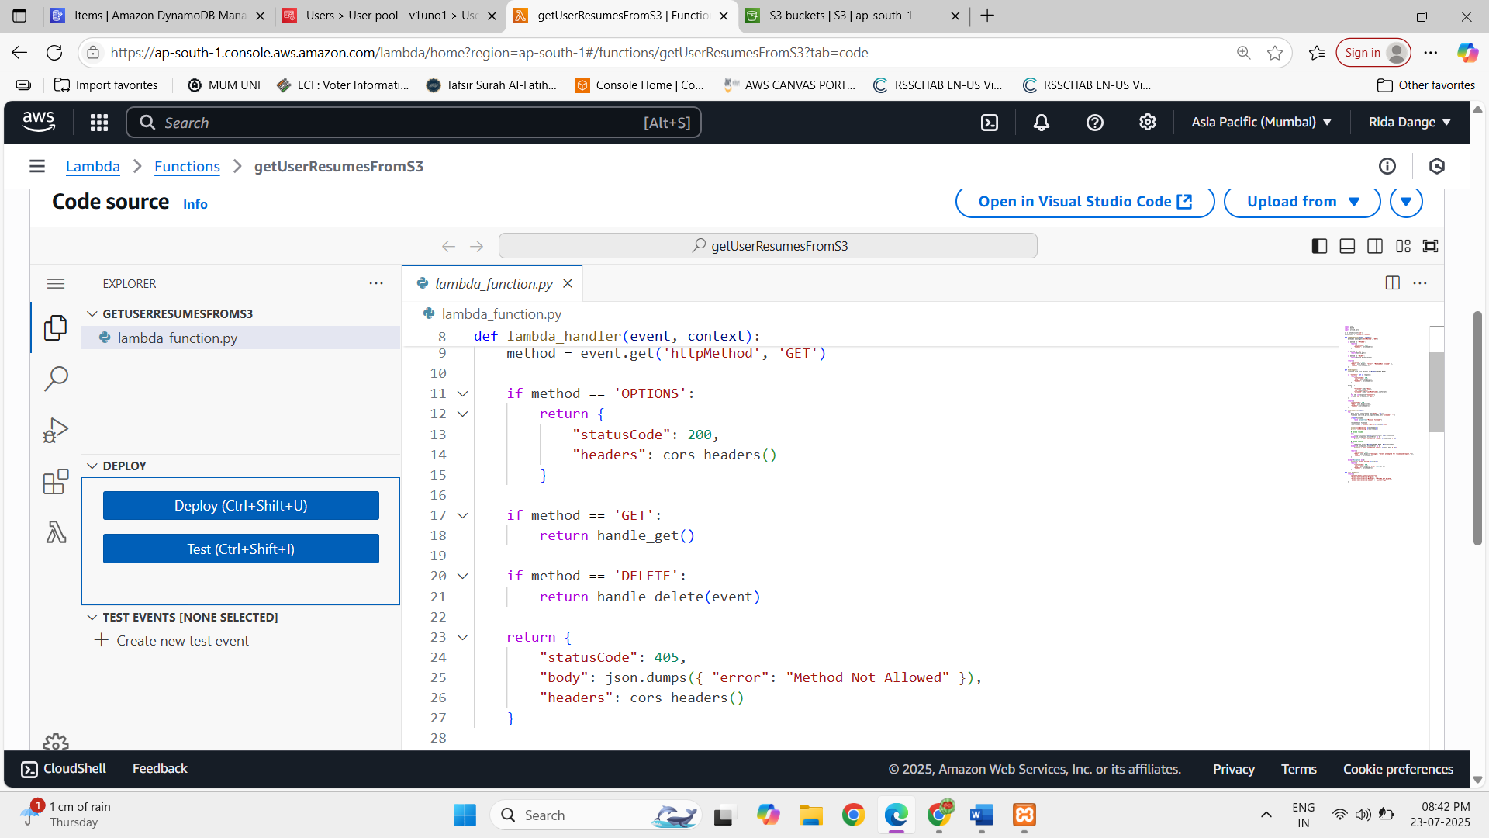

Reusme analysis: Here resume analysis code is written
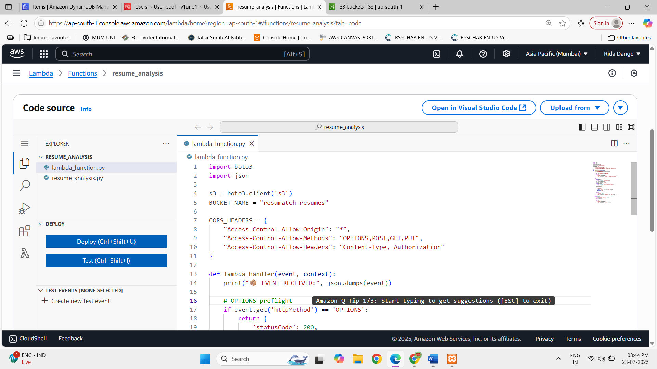

S3 bucket: Here resume which is uploaded from frontend is stored in S3
